Design and Development of a Real-Time Flow-Based Intrusion Detection and Security Management System Using a Two-Stage Ensemble Model
Jimson A. Olaybar¹, Patrick D. Cerna²

^{1,2}College of ICT and Engineering, State University of Northern Negros, Sagay City, Negros Occidental, Philippines
¹FCSIT, Southern Leyte State University – Main Campus, Sogod, Southern Leyte, Philippines

¹jolaybar@southernleytestateu.edu.ph

ABSTRACT

The increasing complexity of modern network environments has heightened the need for practical and scalable intrusion detection solutions. This study presents the development of a real-time, flow-based Intrusion Detection and Security Management System (IDSMS) that integrates live traffic monitoring, machine learning-based intrusion analysis, centralized data storage, and web-based visualization. The system captures network traffic from a MikroTik-based gateway using a passive flow sniffer deployed on a Kali Linux monitoring node. Packets are aggregated into bidirectional flows and transformed into statistical feature vectors, which are analyzed by a machine learning inference service through an application programming interface. Detection results, including risk level and attack classification, are stored in a centralized database and presented through an interactive dashboard. Development-stage testing using simulated attack traffic demonstrates the system's ability to capture, analyze, and visualize network threats in real time. The proposed system provides a practical foundation for deployment in shared-access networks, small enterprises, and IoT-enabled environments.

Keywords — Intrusion Detection System, Flow-Based Analysis, Machine Learning, Network Security, Real-Time Monitoring

1. INTRODUCTION

The rapid growth of networked systems, including enterprise networks, Internet cafés, public Wi-Fi services, and IoT-enabled environments, has significantly increased exposure to cyber threats. Modern attacks such as port scanning, brute-force login attempts, DNS amplification, and distributed denial-of-service (DDoS) attacks continue to evolve in scale and sophistication, making traditional signature-based intrusion detection systems (IDS) insufficient for real-time protection [1], [4].

Recent studies emphasize the effectiveness of flow-based intrusion detection, which analyzes statistical properties of network flows rather than packet payloads. This approach enables efficient monitoring of encrypted traffic while reducing computational overhead, making it suitable for real-time and resource-constrained environments [2], [3], [7]. Machine learning (ML) and deep learning techniques further enhance flow-based IDS by learning complex traffic patterns and improving anomaly detection accuracy [6], [14], [22].

Despite advances in detection models, many existing IDS studies focus primarily on offline datasets and lack full system integration, limiting their applicability in operational networks [4], [10]. Real-world deployment requires not only accurate models but also live traffic capture, scalable inference, centralized logging, and actionable security management interfaces. Furthermore, public-access networks such as pisonet or shared Wi-Fi services demand IDS solutions capable of identifying malicious client devices while preserving normal user traffic. Recent studies have demonstrated the feasibility of anomaly detection and traffic pattern analysis in real-world Pisonet environments using dynamic time warping and seasonal decomposition techniques [25], [26].

To address these challenges, this study presents the development and implementation of a real-time flow-based Intrusion Detection and Security Management System (IDSMS). The proposed system integrates live network traffic capture, flow-level feature extraction, machine learning-based attack classification, and a web-based security management platform. The system is designed to operate with a MikroTik gateway and downstream routers, enabling visibility into client-generated traffic while supporting real-time detection and response.

Unlike dataset-only approaches, this work emphasizes end-to-end system development, demonstrating how flow-based IDS concepts can be operationalized into a working security platform. The system architecture supports live monitoring, historical analysis, and threat management, providing a practical foundation for deployment in small enterprise networks, IoT environments, and public internet access services.

2. OBJECTIVES OF THE STUDY

This study aims to design, develop, and evaluate a comprehensive flow-based intrusion detection system with integrated security management capabilities. Specifically, the objectives are:

- To design and implement a real-time flow-based network monitoring system capable of capturing live traffic from a MikroTik gateway environment without disrupting normal network operations.
- To develop a machine learning-based intrusion detection engine that utilizes a two-stage ensemble approach for binary classification (benign vs. malicious traffic) and multi-class attack classification.
- To create an integrated security management platform featuring centralized data storage, web-based visualization, and real-time threat monitoring capabilities.
- To validate the system functionality through development-stage testing using simulated attack traffic and evaluate its operational feasibility for deployment in shared-access network environments.

3. SCOPE OF THE STUDY

This research focuses on the following scope:

- Geographical and Institutional Scope: The study is conducted within the network infrastructure of the State University of Northern Negros, Philippines, with applicability to similar educational institutions and small-to-medium enterprise environments.
- Technical Scope:
  - Network environment: MikroTik router-based gateway with downstream routers
  - Monitoring platform: Kali Linux virtual machine
  - Detection approach: Flow-based analysis using statistical features
  - Machine learning framework: Two-stage ensemble model
  - System integration: Python-based implementation with web dashboard
- Temporal Scope: The development and testing phase was conducted during the 2024-2025 academic year, with system validation performed under controlled laboratory conditions.
- Functional Scope: The system includes live traffic capture, flow aggregation, feature extraction, machine learning inference, database logging, and web-based visualization components. Automated mitigation actions are excluded from the current implementation.
- Limitation Scope: Evaluation is limited to development-stage testing with simulated attack traffic; large-scale real-world deployment and performance benchmarking are designated as future work.

4. SIGNIFICANCE OF THE STUDY

This research holds significant value for multiple stakeholders in the cybersecurity and network management domains:

4.1 For Educational Institutions
The system provides a cost-effective intrusion detection solution for universities and colleges with limited cybersecurity budgets, particularly relevant for Philippine higher education institutions facing resource constraints.

4.2 For Network Administrators
The integrated security management platform offers real-time visibility into network threats, enabling proactive security monitoring and informed decision-making for network administrators in small-to-medium enterprises.

4.3 For Cybersecurity Researchers
The study contributes to the body of knowledge on practical implementation of flow-based IDS, addressing the research gap between theoretical models and operational deployment. The modular architecture serves as a reference for future system development.

4.4 For Public Internet Service Providers
The system's design accommodates shared-access environments like pisonet and public Wi-Fi services, providing a framework for monitoring client-originated threats while maintaining service availability.

4.5 For IoT Network Operators
The flow-based approach's compatibility with encrypted traffic makes the system applicable to IoT environments where payload inspection is impractical or impossible.

4.6 For Developing Economies
The use of open-source tools and modular design provides a blueprint for affordable cybersecurity solutions in resource-constrained settings, contributing to digital security in developing regions.

5. RELATED STUDIES

5.1 Flow-Based Intrusion Detection Foundations
Flow-based intrusion detection has emerged as a scalable alternative to payload inspection, particularly for monitoring encrypted traffic. Satheesh et al. [1] demonstrated early integration of flow-based anomaly detection with SDN/OpenFlow environments, establishing the feasibility of flow-driven security monitoring in programmable networks. Pontes et al. [2] introduced a novel detection method using the inverse Potts model, showing that flow representations can capture complex network behaviors beyond traditional feature engineering. For wireless environments, Segura-Garcia et al. [3] developed HeaderHunter, a real-time flow-based IDS for IEEE 802.11 networks, validating the practicality of flow-level monitoring in wireless systems.

5.2 Standardization and Dataset Development
A persistent challenge in flow-based IDS research is feature definition inconsistency and dataset variability. Sarhan et al. [4] emphasized the need for standardized feature sets, noting that differences in extraction and labeling procedures limit reproducibility. Several datasets have been developed to address these issues, including Edge-IIoTset by Ferrag et al. [5] for IoT/IIoT scenarios and the widely adopted CICIDS2017 dataset used in benchmarking studies by Kurniabudi et al. [10] and Maseer et al. [11]. Komisarek and Pawlicki [12] further contributed a refined dataset specifically designed for real-time NIDS settings.

5.3 Machine Learning Integration in IDS
Deep learning approaches have gained prominence for their ability to model complex traffic patterns. Vishwakarma and Kesswani [6] proposed a deep neural network-based real-time IDS for IoT, reporting improved detection performance in constrained environments. Rathore et al. [7] and Fraihat et al. [8] explored flow-driven deep learning models for IoT anomaly detection, while Manocchio et al. [20] introduced FlowTransformer, an attention-based model for learning temporal dependencies within flow records.

5.4 Federated Learning for Distributed Detection
Federated learning has emerged as a privacy-preserving approach for distributed intrusion detection. de Oliveira et al. [13] presented F-NIDS, demonstrating federated intrusion detection without centralized data collection. Doriguzzi-Corin and Siracusa [21] proposed FLAD for adaptive DDoS detection, while Nugraha et al. [22] investigated federated learning with variational autoencoders for anomaly detection.

5.5 Enhancement Techniques and Practical Applications
Several studies have focused on improving IDS reliability through techniques like data augmentation and feature encoding. Mohammad et al. [14] explored deep learning combined with data augmentation, while Alitbi et al. [15] proposed incremental feature encoding for real-time constraints. Recent work has extended flow-based analysis to practical scenarios, including Pisonet traffic analysis [25] and dynamic network visualization [26], highlighting the growing relevance of operational deployment considerations.

5.6 Research Gap Addressed by This Study
While extensive research exists on flow-based IDS models and algorithms, few studies address comprehensive system integration and operational deployment. Most existing work focuses on offline evaluation using datasets, with limited emphasis on end-to-end system implementation. This study addresses this gap by developing a complete Intrusion Detection and Security Management System (IDSMS) that integrates live traffic capture, machine learning inference, centralized storage, and web-based management interfaces.

6. METHODOLOGY

6.1 System Architecture Overview
The proposed IDSMS follows a modular architecture with five primary components: (1) live traffic capture from client devices through router and MikroTik gateway infrastructure, (2) flow aggregation and feature extraction by a dedicated monitoring node, (3) machine learning-based intrusion analysis through an inference service, (4) centralized data storage in a relational database, and (5) web-based visualization and threat management via an interactive dashboard. The system operates within a gateway-based network environment where client traffic passes through routers and a MikroTik gateway, with a dedicated monitoring node performing passive traffic observation and feature extraction before analysis results are stored and visualized.

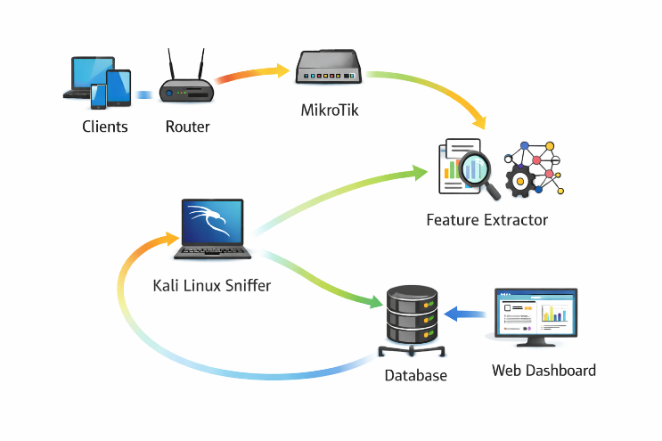
Figure 1. Overall System Architecture Diagram

6.2 Live Traffic Capture and Flow Aggregation
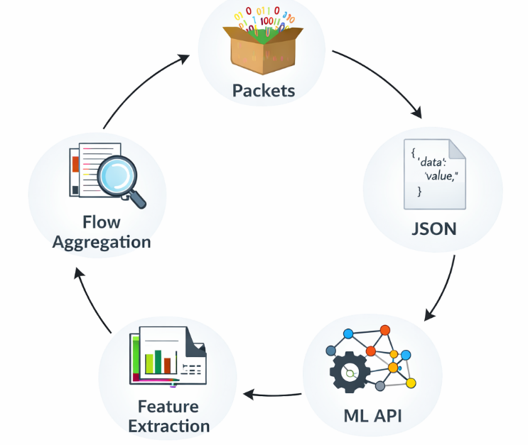
The traffic processing pipeline, illustrated in Figure 2, begins with packet capture using a Python-based flow sniffer on a Kali Linux VM. The system performs flow aggregation by grouping packets into bidirectional flows based on five-tuple identifiers (source/destination IP/port + protocol). Upon flow completion, feature extraction generates approximately 78 statistical attributes per flow. These feature vectors are sent via REST API to a machine learning inference service, which returns JSON-formatted classification results (e.g., {'data': value, 'risk_level': 'high', 'attack_type': 'DDoS'}). Idle timeout mechanisms ensure timely flow termination and feature export.
Figure 2. Flow Capture and Feature Extraction Pipeline
6.3 Feature Extraction and Preprocessing
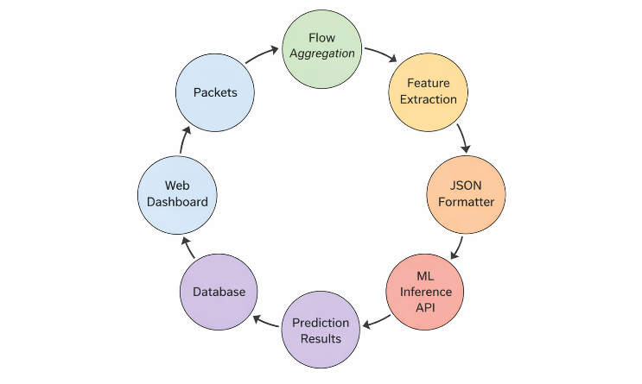
For each completed flow, the system extracts approximately 78 statistical features capturing temporal, volumetric, and directional characteristics. These include flow duration, packet counts, byte rates, inter-arrival times, and forward-backward packet statistics. Following feature extraction, the data undergoes JSON formatting to create structured API payloads. These formatted feature vectors are transmitted to the ML inference API, which performs real-time classification and returns prediction results (including risk level, attack probability, and classification labels). All results are then stored in the centralized database and made available for visualization through the web dashboard. Feature normalization is applied to ensure compatibility with machine learning models, and filtering removes incomplete or insignificant traffic. This complete runtime processing pipeline from packet aggregation through database storage to dashboard visualization is shown in Figure 3.
Figure 3. Runtime Data Processing Pipeline of the Proposed IDSMS
6.4 Machine Learning Model Design and Training

6.4.1 Two-Stage Ensemble Architecture
The intrusion detection engine employs a two-stage ensemble approach:
- Stage A: Binary classification (benign vs. malicious) using a calibrated stacking ensemble of Random Forest, Gradient Boosting, and XGBoost classifiers with Logistic Regression as meta-classifier
- Stage B: Multi-class attack classification using a Random Forest classifier trained exclusively on malicious samples

6.4.2 Training Process
Models were trained offline using the CIC-IDS2017 dataset with 78 numerical flow-based features. Preprocessing included feature normalization using standard scaling and removal of identifier-based fields (IP addresses, ports) to prevent information leakage. Probability calibration and threshold optimization were applied in Stage A to address class imbalance.

6.5 Machine Learning Inference Integration
Extracted flow features are transmitted to a remote inference service via secure API. The service returns structured outputs including risk level, attack probability, and attack classification. This decoupled design enables independent model updates without modifying the traffic capture infrastructure.

6.6 Data Storage and Logging
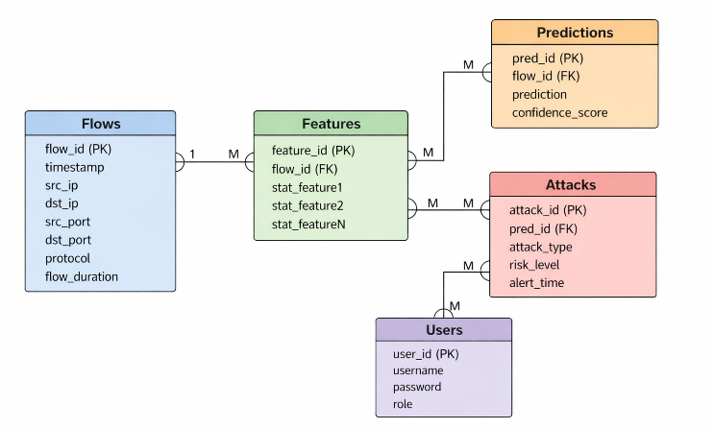
A centralized relational database implements the storage layer with a normalized schema consisting of five primary tables: Flows (flow metadata), Features (extracted attributes), Users (access control), Predictions (classification outputs), and Attacks (threat records). This structure ensures comprehensive logging of all processed traffic while supporting efficient queries for both real-time monitoring and historical forensic analysis, as detailed in Figure 4.

Figure 4. Database Schema of the Proposed IDSMS
6.7 Web-Based Security Management Interface
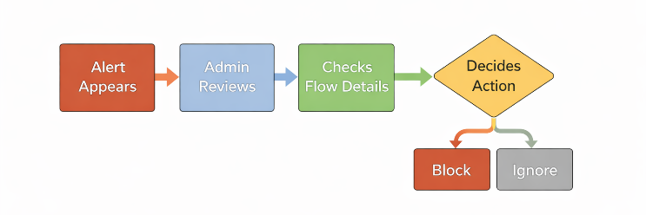
A web dashboard provides visualization and management capabilities, displaying metrics such as total flows processed, detected attacks, attack rates, and risk-level distributions. The interface includes time-series graphs, attack distribution charts, and interactive tables for detailed flow inspection. The dashboard supports an interactive security analyst workflow where: (1) an alert appears in the interface, (2) the admin reviews the alert details, (3) checks flow-specific information, (4) decides on an action, and (5) selects either to block the malicious traffic or ignore the alert. This decision-making process is illustrated in Figure 5.

Figure 5. Security Analyst/Admin Decision-Making Workflow

6.8 Experimental Deployment Environment
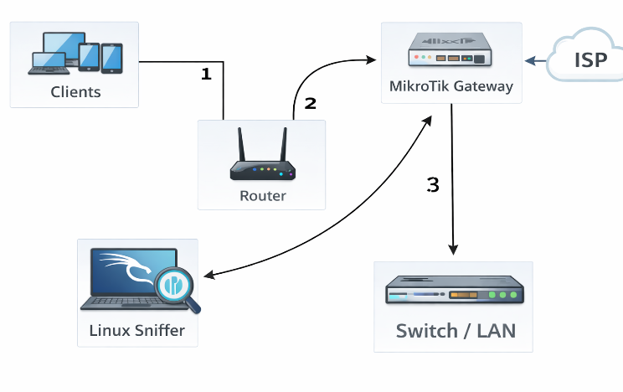
The system was deployed in a virtualized VMware environment with the following network topology: client devices (1) connect to a router (2), which forwards traffic through a MikroTik gateway (3) linked to an ISP for external access. A dedicated Kali Linux sniffer node is positioned to monitor traffic via a switch/LAN connection, enabling passive observation of all network activity. This setup facilitates controlled experimentation while emulating real-world network behavior, as illustrated in Figure 6.

Figure 6. Network Deployment Topology

7. RESULTS AND DISCUSSIONS

7.1 Flow Capture and Traffic Visibility Validation
During testing, the flow sniffer successfully captured live traffic and aggregated packets into bidirectional flows. The system consistently recorded flow metadata (duration, packet count, byte volume) and differentiated traffic from multiple client devices, confirming its suitability for shared-access environments. The successful extraction of flow-level statistics aligns with established flow-based IDS research [1], [3].

7.2 Real-Time Monitoring Performance
Figure 7 illustrates the Live Monitor interface of the IDSMS, which provides immediate visibility into network activity through real-time metrics and graphical displays. The dashboard shows live statistics such as incoming flows (38), packets per second (31), and alerts per second (0), alongside a time-series graph depicting flow rate variations over a monitoring period. This real-time visualization confirms the system’s capability to process and display traffic fluctuations instantly, a critical feature for environments requiring continuous situational awareness and prompt threat response.
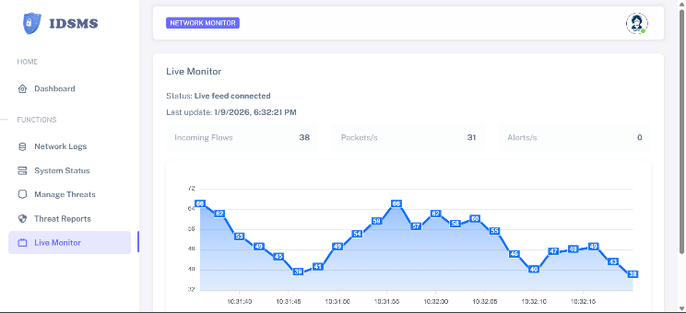
Figure 7. Real-time monitoring interface of the proposed IDSMS showing live flow rate and packet activity

7.3 Feature Generation Consistency
The system generated structured feature vectors with approximately 78 statistical attributes per flow. Key metrics including flow duration, packets per second, bytes per second, and inter-arrival time statistics showed consistency across repeated traffic patterns. During simulated attacks, abnormal behaviors (high packet rates, short inter-arrival times) produced elevated metrics, demonstrating feature sensitivity to anomalies as supported by prior research [4], [10].

7.4 Machine Learning Inference Results
Feature transmission to the inference API occurred without data loss, with the service returning classification results, probability scores, and attack labels. Simulated attack traffic produced elevated probability scores and appropriate attack classifications, validating the inference pipeline's functionality. The probabilistic output format enables nuanced risk assessment, consistent with modern IDS design principles [6], [14].

7.5 Detection Performance of Integrated ML Engine

The integrated two-stage ensemble achieved exceptional performance metrics:

Table 1. Detection Performance of Integrated Machine Learning Engine
Stage | Task | Accuracy | ROC-AUC
Stage A | Binary Classification (Benign vs Attack) | 99.92% | 0.99987
Stage B | Multi-class Classification (14 attack types) | 99.83% | -

Stage A demonstrated near-perfect discrimination capability with 99.92% accuracy and ROC-AUC of 0.99987. Stage B achieved 99.83% accuracy across fourteen attack categories, confirming reliable specific attack identification. These results validate the detection engine's suitability for real-time deployment.

7.6 Database Logging and Data Integrity
All analyzed flows and predictions were successfully stored in the centralized database with correct field population across multiple test runs. The persistent storage enables historical analysis and forensic review, adhering to best practices for real-time IDS deployment [12].

7.7 Dashboard Visualization Effectiveness

Figures 8 illustrate the dashboard’s comprehensive visualization capabilities, which include real-time attack summaries (118 malicious flows detected), traffic overview graphs, and detailed breakdowns of attack types and risk distributions. The interface successfully reflected simulated attack patterns showing spikes in threat activity and updating attack rate metrics dynamically thereby validating the end-to-end synchronization of the IDSMS pipeline.
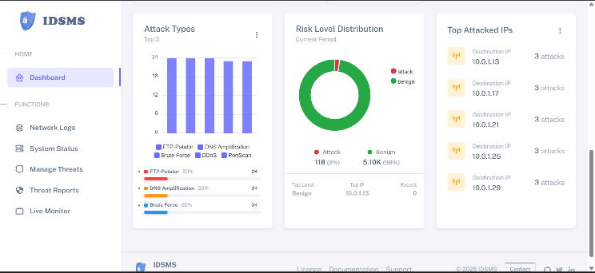

Figure 8. Dashboard Screenshot (Overview Page)
The Threat Reports module, shown in Figure 10, demonstrated real-time synchronization across the IDSMS by displaying live summary metrics—including 118 detected attacks out of 5,214 total events—and populating a detailed event log table with timestamped flow records, source and destination IPs, risk classifications, probability scores, and traffic statistics as soon as simulated attacks were processed. This immediate update of both numerical counters and forensic data validated the system’s end-to-end operational pipeline, confirming that packet capture, feature extraction, machine learning inference, database storage, and dashboard visualization were seamlessly integrated with negligible latency, thereby proving the system’s readiness for real-world security monitoring where timely threat awareness is essential.
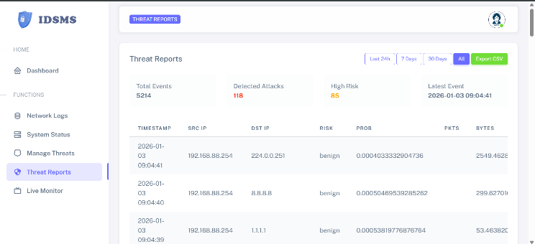
Figure 9. Threat Reports module of the IDSMS showing summarized statistics and per-flow event records.
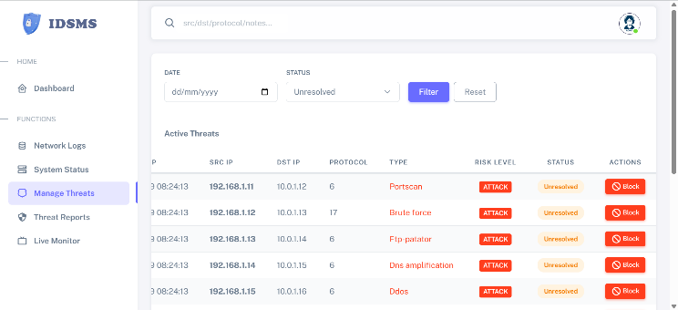
Figure 10 presents a tabular view of specific attack instances detected during testing, displayed within the Manage Threats interface. The table includes detailed forensic records such as timestamps, source and destination IP addresses, protocol identifiers, attack types (Portscan, Brute Force, FTP Patator, DNS Amplification, DDoS), risk levels, status indicators, and actionable block options. This structured presentation of live threat data validates the system’s classification accuracy and provides security analysts with immediate, actionable forensic details for incident investigation and response.

Figure 10: Sample table of Detected Testing Attacks
7.8 System Integration and Operational Feasibility
The results confirm successful integration of all system components, with reliable end-to-end operation from packet capture through visualization. Compared to prior studies focusing on isolated models [4], [10], this work demonstrates practical system implementation suitable for real-world environments requiring continuous monitoring and actionable insights.

7.9 Limitations of Current Evaluation
The evaluation is limited to development-scale testing with simulated attacks and constrained client numbers. While functional validation is successful, large-scale deployment with diverse traffic patterns and genuine attacks is needed to fully assess detection accuracy and scalability.

8. CONCLUSIONS

8.1 Summary of Findings
This study successfully designed, developed, and evaluated a real-time flow-based Intrusion Detection and Security Management System (IDSMS). The system integrates live network traffic monitoring, machine learning-based intrusion analysis, centralized data storage, and web-based visualization into a cohesive security platform. Key achievements include:

- Successful implementation of a modular architecture separating traffic acquisition, analysis, storage, and visualization components
- Effective flow capture and feature extraction from MikroTik gateway environments
- High-performance detection using a two-stage ensemble machine learning approach (99.92% binary accuracy, 99.83% multi-class accuracy)
- Functional integration of all system components with reliable end-to-end operation
- Practical visualization through an interactive web dashboard supporting real-time monitoring and historical analysis

8.2 Contributions to Knowledge and Practice
This research makes several important contributions:

- Practical Implementation Focus: Unlike many IDS studies concentrating on algorithmic improvements, this work emphasizes system-level design and operational deployment
- Integration Framework: Provides a blueprint for integrating machine learning models into operational security systems
- Resource-Constrained Solutions: Demonstrates affordable cybersecurity implementation using open-source tools
- Shared-Access Environment Applicability: Addresses the specific needs of public internet access services and educational institutions

8.3 Recommendations for Implementation
Based on the findings, the following implementation recommendations are provided:

- Institutional Deployment: Educational institutions should consider similar flow-based IDS implementations for cost-effective network security
- Configuration Guidelines: Network administrators should ensure proper traffic mirroring configurations and adequate monitoring node resources
- Model Maintenance: Regular retraining of machine learning models with updated attack patterns is essential for sustained effectiveness
- Scalability Planning: Organizations should plan for database scaling and distributed processing for larger deployments

8.4 Future Research Directions
The following areas warrant further investigation:
- Large-Scale Real-World Deployment: Testing in operational networks with diverse traffic patterns and genuine attacks
- Automated Response Integration: Implementing dynamic firewall rule enforcement and automated mitigation actions
- Adaptive Learning Approaches: Exploring federated and continuous learning for model improvement
- Performance Benchmarking: Comparative evaluation against commercial and open-source IDS solutions
- Extended Network Environments: Adaptation for cloud-based, SDN, and 5G network infrastructures

8.5 Final Remarks
The developed IDSMS provides a practical foundation for intrusion detection in resource-constrained environments, particularly relevant for educational institutions and small enterprises in developing economies. By bridging the gap between theoretical models and operational systems, this research contributes to more accessible and implementable cybersecurity solutions. The modular design ensures adaptability to evolving network threats and technologies, supporting long-term security management needs.

REFERENCES

[1] Satheesh, N., Rathnamma, M. V., Rajeshkumar, G., et al. (2020). Flow-based anomaly intrusion detection using machine learning model with software defined networking for OpenFlow network. Microprocessors and Microsystems, 79, 103285.

[2] Pontes, C. F. T., de Souza, M. M. C., Gondim, J. J. C., Bishop, M., & Marotta, M. A. (2021). A New Method for Flow-Based Network Intrusion Detection Using the Inverse Potts Model. IEEE Transactions on Network and Service Management, 18(2), 1125–1136.

[3] Segura-Garcia, J., Garcia-Pineda, M., & Felici-Castell, S. (2021). HeaderHunter: A flow-based, real-time intrusion detection system for IEEE 802.11 networks. Sensors, 21(4), 1140.

[4] Sarhan, M., Layeghy, S., & Portmann, M. (2022). Towards a Standard Feature Set for Network Intrusion Detection System Datasets. Mobile Networks and Applications, 27(1), 357–370.

[5] Ferrag, M. A., Friha, O., Hamouda, D., Maglaras, L., & Janicke, H. (2022). Edge-IIoTset: A New Comprehensive Realistic Cyber Security Dataset of IoT and IIoT Applications for Centralized and Federated Learning. IEEE Access.

[6] Vishwakarma, M., & Kesswani, N. (2022). DIDS: A deep neural network based real-time intrusion detection system for IoT. Decision Analytics Journal, 5, 100142.

[7] Rathore, H., et al. (2023). An anomaly-based IDS for IoT using NetFlow features and deep learning. Neural Computing and Applications.

[8] Fraihat, S., et al. (2023). Intelligent intrusion detection in IoT networks using NetFlow-based traffic and ML (IoT-focused). Internet of Things.

[9] Jablaoui, R., Cheikhrouhou, O., Hamdi, M., & Liouane, N. (2025). Deep learning enabled intrusion detection system for IoT security. EURASIP Journal on Wireless Communications and Networking, 2025(1).

[10] Kurniabudi, Stiawan, D., Darmawijoyo, Idris, M. Y., & Bamhdi, A. M. (2020). CICIDS-2017 Dataset Feature Analysis with Information Gain for Anomaly Detection. IEEE Access, 8, 132911–132921.

[11] Maseer, Z. K., Yusof, R., Bahaman, N., Mostafa, S. A., & Foozy, C. F. M. (2021). Benchmarking of Machine Learning for Anomaly Based Intrusion Detection Systems in the CICIDS2017 Dataset. IEEE Access, 9, 22351–22370.

[12] Komisarek, M., & Pawlicki, M. (2022). A novel, refined dataset for real-time Network Intrusion Detection. In Proceedings of the 17th International Conference on Availability, Reliability and Security (ARES 2022).

[13] de Oliveira, J. A., Gonçalves, V. P., Meneguette, R. I., de Sousa Jr, R. T., Guidoni, D. L., Oliveira, J. C. M., & Rocha Filho, G. P. (2023). F-NIDS — A Network Intrusion Detection System based on federated learning. Computer Networks, 236, 110010.

[14] Mohammad, R., Saeed, F., Almazroi, A. A., Alsubaei, F. S., & Almazroi, A. A. (2024). Enhancing Intrusion Detection Systems Using a Deep Learning and Data Augmentation Approach. Systems, 12(3), 79.

[15] Alitbi, Z. K., Hosseini Seno, S. A., Ghaemi Bafghi, A., & Zabihzadeh, D. (2025). A Generalized and Real-Time Network Intrusion Detection System Through Incremental Feature Encoding and Similarity Embedding Learning. Sensors, 25(16), 4961.

[16] Mutambik, I. (2024). An efficient flow-based anomaly detection system for enhanced security in IoT networks. Sensors, 24(22), 7408.

[17] Callegari, C., Giordano, S., & Pagano, M. (2024). A real-time deep learning-based approach for detecting network attacks. Big Data Research, 36, 100446.

[18] Gheni, H. Q., & Al-Yaseen, W. L. (2024). Two-step data clustering for improved intrusion detection system using CICIoT2023 dataset. e-Prime — Advances in Electrical Engineering, Electronics and Energy, 9, 100673.

[19] Sayed, N., Baskar, S., Ramachandran, M., et al. (2023). Augmenting IoT intrusion detection system performance using deep neural network. CMC—Computers, Materials & Continua, 74(1).

[20] Manocchio, L. D., Layeghy, S., Lo, W. W., et al. (2023). FlowTransformer: A transformer framework for flow-based network intrusion detection systems. Expert Systems with Applications, 241, 122564.

[21] Doriguzzi-Corin, R., & Siracusa, D. (2023). FLAD: Adaptive federated learning for DDoS attack detection. Computers & Security, 137, 103597.

[22] Nugraha, K. D., Kota, V. R., & Rupp, M. (2024). Leveraging federated learning and variational autoencoders for an enhanced anomaly detection system. IEEE NetSoft 2024.

[23] Devine, M., Ardakani, S. P., Al-Khafajiy, M., & James, Y. (2025). Federated machine learning to enable intrusion detection systems in IoT networks. Electronics, 14(6), 1176.

[24] Buyuktanir, O., Nandi, D., & Goyal, N. (2025). A review of federated learning applications in intrusion detection systems. Cluster Computing.

[25] Saligue, R. Y., & Saligue, E. T. (2025). Real-World Traffic Analysis in Pisonet using DTW and Anomaly Detection. In 2025 7th International Conference on Innovative Data Communication Technologies and Application (ICIDCA). IEEE.

[26] Saligue, R. Y., Saligue, E. T., Teofilo, L. M., Sy, K. N. L., & Cerna, P. D. (2025). Dynamic Analysis and Visualization of Network Traffic Patterns using Machine Learning and Seasonal Decomposition Techniques. In 2025 5th International Conference on Soft Computing for Security Applications (ICSCSA). IEEE.

